Rotary Club of Kathmandu Mid-Town
Breakfast Chatter




3 February 2012 The Weekly Bulletin of Rotary Club of Kathmandu Mid-Town Bc-2.03/011-12

District: 3292 Web: www.rotarymidtown.org.np Club Id : 26776

FEBRUARY IS WORLD UNDERSTANDING MONTH
Advancing world understanding and peace, which is expressed in the fourth part of the Object of Rotary,
is an important focus of Rotarian service. It is the impetus for numerous service efforts and other cooperative ventures among Rotarians from different parts of the world. It is the reason Rotary International has a longstanding, close collaboration with the United Nations and many of its member agencies.
Appropriately, every year the anniversary of the founding of Rotary, 23 February, is celebrated as World Understanding and Peace Day.

27 January, Friday:
Mr. Kiran Joshi, CEO of Incessant Rain Co Ltd, was our guest speaker for the day. Mr Joshi talked about immense scope in the field of animation in Nepal. He briefed on his interest in branding Nepal in this field and this brought him back to Nepal from his work with Walt Disney. Upon return he established a company and has been working in this field for its promotion and branding Nepal. He hopes to promote Nepali characters and themes such as Yeti, laddu and jilebees etc.
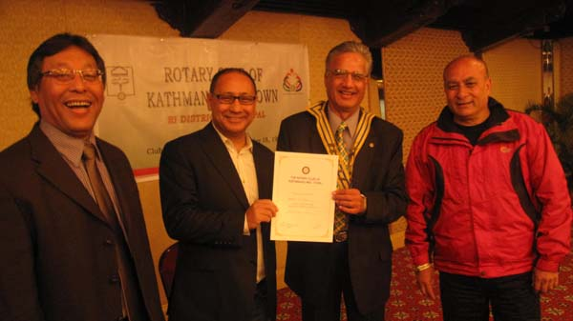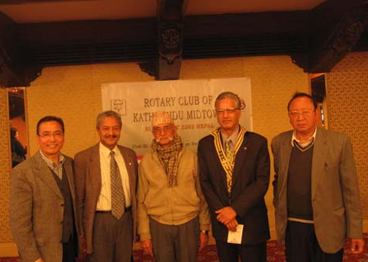
President Som presenting certificate of appreciation to guest >< Rishi Bogati, Local contact, Gorkha-Lamjung girls
speaker Kiran Joshi flanked by Club Adm Chair Govinda and education project, with Mid-Towners: PP Mani,
TRF Chair Buddha. IPP Pratap, President Som and Service Projects
Chair PP Arun.

Weekly Meetings and Programs :
Date | Program/Speaker | Program/Topics of Presentation
3 February 2012 | PP Mani D Joshi | The Rotary Foundation Strategies
10 February 2012 | Dr Yogendra Bhakta | Spiritualism: Shivapuri Baba
17 February 2012 | Dr. Suman Thapa | Glaucoma / Healthy eyes

Rotary’s Challenge reaches US$200 million:
Rotary’s Challenge for polio eradication has reached the US$200 million milestone. The Bill & Melinda Gates Foundation has awarded The Rotary Foundation an additional $50 million grant, which is not a challenge grant, in recognition of Rotary's early achievement of this milestone.
Source: Rotary International News

‘Peace Through Service’ is 2012-13 RI theme:
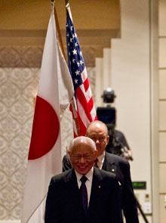
RI President-elect Sakuji Tanaka began the weeklong training event by
asking the 530 governors-elect to build Peace Through Service.
Tanaka unveiled the RI theme during the opening plenary session of the
2012 International Assembly, a training event for incoming Rotary district
governors.
"Peace, in all of the ways that we can understand it, is a real goal and a
realistic goal for Rotary," he said. "Peace is not something that can only
be achieved through agreements, by governments, or through heroic
struggles. It is something that we can find and that we can achieve, every
day and in many simple ways."
Peace has different meanings for different people, Tanaka said.
"No definition is right, and no definition is wrong," he said. "However we
use the word, this is what peace means for us.
"No matter how we use, or understand the word, Rotary can help us to
achieve it," he added.
“In Rotary, our business is not profit. Our business is peace,” he said.
“Our reward is not financial, but the happiness and satisfaction of seeing a better, more peaceful world, one that we have achieved through our own efforts.”
Source: Rotary International News



We need to commit ourselves absolutely and fully and say, What I must do shall indeed be
done.
RI President Kalyan Banerjee

Astronomers discover 18 huge new alien planets:
Astronomers have found 18 new alien planets, all of them Jupiter-size gas giants that circle stars bigger than our sun, a new study reports.
The haul comes just a few months after a different team of researchers announced the discovery of 50 newfound alien worlds including one rocky planet that could be a good candidate for life.
The list of known alien planets is now well over 700 and climbing fast.
Source: The Rising Nepal

A thought for the day:
There is no exception to the rule that every rule has an exception !
James Thurber

On Lighter Side :
Click here ⇩



Never give up !!

Please send project/activity information, suggestions and photos etc to :
BC Editor: RR Shrestha email: rryes@wlink.com.np

3 February 2012 The Weekly Bulletin of Rotary Club of Kathmandu Mid-Town bc-2.03/011-12

